WEEK 5
Examination of a website to test the vulnerability of attacks. – XSS & CSRF & Command line injection attack
Program:-

1. Cross-Site Scripting (XSS) Attack

Objective
Identify whether a web application accepts and executes malicious JavaScript code.

Steps
- Open DVWA.
- Login to the application.
- Navigate to XSS (Reflected) or XSS (Stored) module.
- Set Security Level to Low.
- Enter the following payload in the input field:
<script>alert('Attack')</script>
- Submit the form.
- Observe whether a popup alert appears.

Expected Result
If the alert box appears, the application is vulnerable to XSS.

2. Cross-Site Request Forgery (CSRF) Attack

Objective
Determine whether a user can be tricked into performing unwanted actions.

Steps
- Open DVWA.
- Navigate to CSRF module.
- Set Security Level to Low.
- Change password and test credentials

Expected Result
The victim's password changes without explicit authorization.

3. Command Injection Attack

Objective
Check whether user input is executed as an operating system command.

Steps
- Open DVWA.
- Navigate to Command Injection module.
- Set Security Level to Low.
- Enter a valid IP address:
127.0.0.1
- Verify normal output.
- Try appending a command:
Linux:
127.0.0.1&&net user
or
127.0.0.1 | ls
- Submit the request.

Expected Result
If additional command output is displayed, the application is vulnerable to command injection.
Output:-
Command line Injection Attack
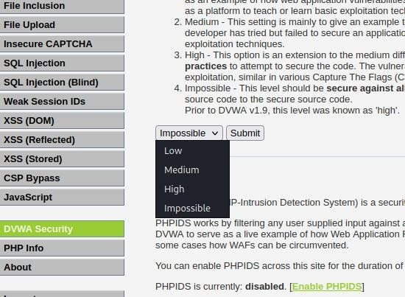
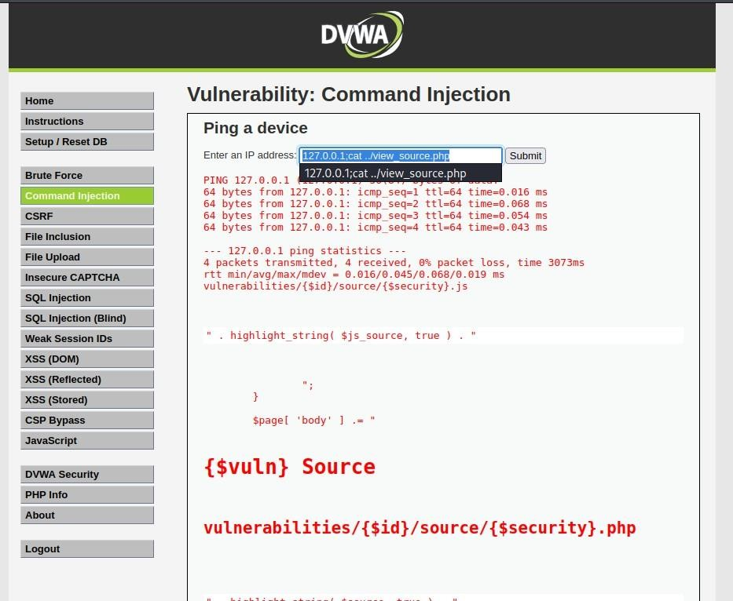
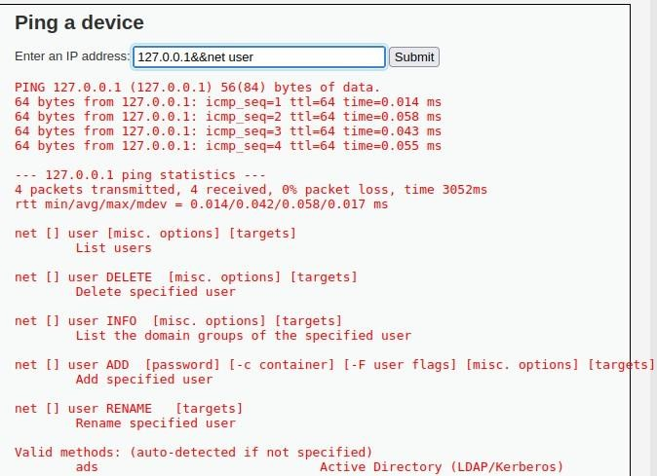

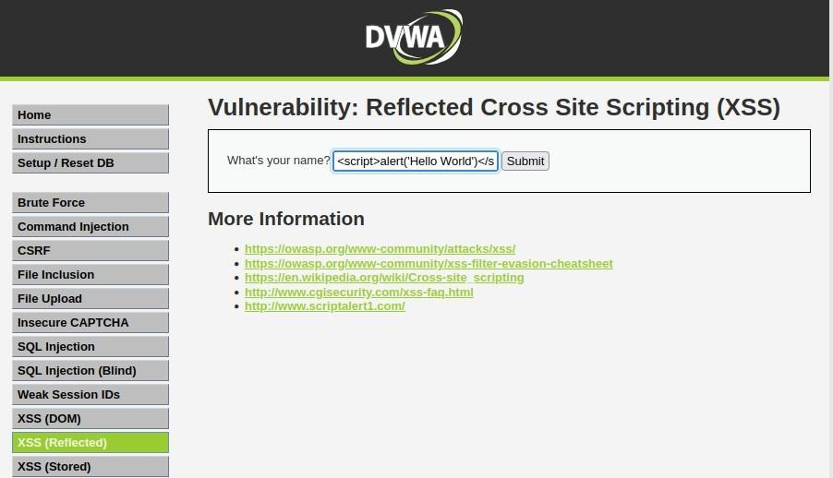
XSS Attack:-
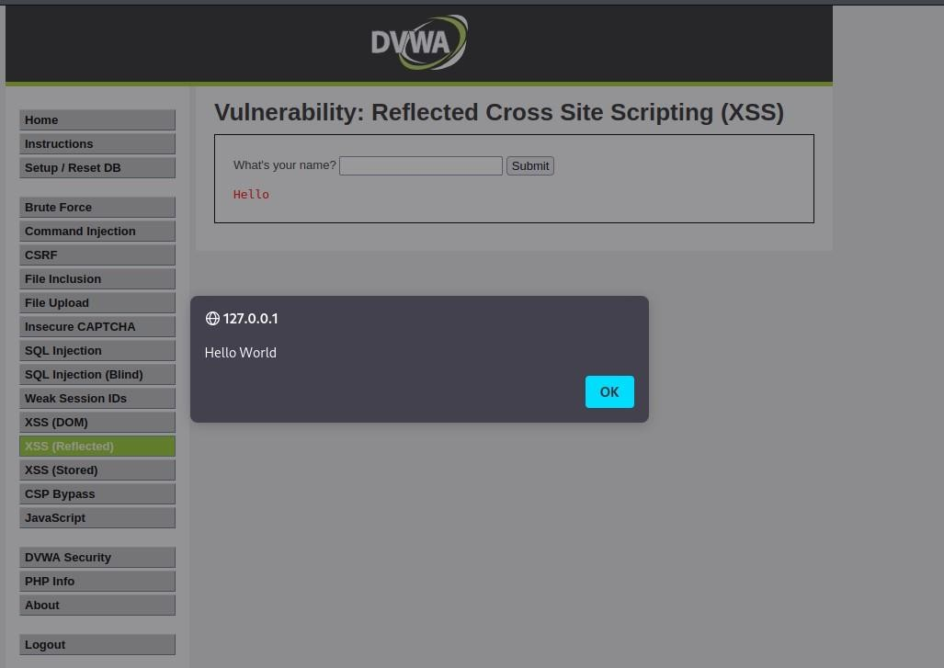

CSRF ATTACK:-
